**IBM NAAN MUDHALVAN PROJECT**

**PROJECT TITLE: FLOOD MONITORING SYSTEM**

**COLLEGE NAME AND CODE: PERI INSTITUTE OF TECHNOLOGY [4115]**

**DEPT: ELECTRONICS AND COMMUNICATION ENGINEERING**

**DOMAIN: INTERNET OF THINGS (IOT)**

**Submitted By**

**SILAMBARASAN.S -(au411521106052)**

**PHASE-2**

**Innovation:**

This study is conducted to solve the problems brought about by floods. The device shall contain with the following features: It has ultrasonic sensor to sense the distance of water level of flood on the road. The system provided a camera that will display the real-time image of the flood that can view via livestream. It includes Serial Communication to send warning text message with the content of date, time, water level and road accessibility. The system has three (3) modules which are Users, Logs, and Contact Numbers. It can be modify by the admin. The unit containing the sensor is suggested to be place in front of Our system. The position of the sensor must be placed perpendicular to the flood water; otherwise, there will be an imperfect reflection of ultrasonic waves and cause measurement errors. The sensor is suggested to be placed on a pole with a height of about 3 to 3.5 meters. The flood sensors and microcontrollers will be powered by a Solar Power Bank with 80, 000 Ampere Ampere-Hour (mAh) for the benefit of continuous operation of water flood height detection and network data transmission.

**How it works:**

A clean and clear DFD can clearly show the right amount of system requirement. It can be manual, automatic, or a combination of both. Indicates how data enters and leaves the system, what changes the data, and where the data is stored. The purpose of the DFD is to indicate the size and parameters of the entire system. It can be used as a communication tool between a program analyst and any person who plays a role in an order that serves as the starting point for program rebuilding.

**FLOW DIAGRAM:**

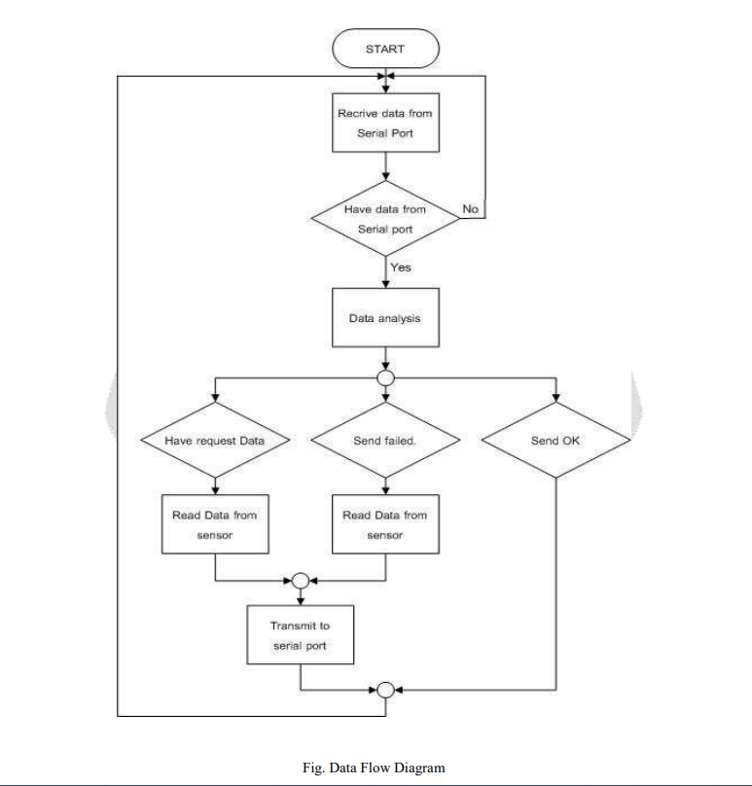

**Conclusion:**

The study is all about detecting the level of the flood. Based from the existing way of reporting flooded roads in India have concluded that the Flood Detector System using Arduino can measure the height of the flood; and measurement data can be distributed to officer in charge and to the residents. The system also indicate passable and impassable road that will help commuters to avoid getting stuck in an impassable road. The system also provides camera to easily monitor the flood.